Deep-Emotion: Facial Expression Recognition

Project submitted to

SRM University - AP, Andhra Pradesh

for the partial fulfillment of the requirements to award the degree of

Bachelor of Technology in
Computer Science and Engineering School
of Engineering and Sciences

Submitted by

V HARSHA VARDHAN – AP22110010677
SK JAHEER - AP21110010551
CH RUCHIRA – AP22110010570



Under the supervision of

Dr Neeraj Kumar Sharma

SRM University
Neerukonda, Mangalagiri, Guntur
Andhra Pradesh - 522240
April 2024

Certificate
Date: 28-April-25

This Is to certify that the work presented in this project entitled “Deep Emotion-Facial Expression Recognition” has been carried out by out V Harsha Vardhan, SK Jaheer, CH Ruchira as a part of course project under my supervision. The work is original and suitable for submission to SRM University – AP for the award of project completion in the degree of Bachelor of Technology in the School of Engineering and Sciences.

Advisor

(Signature)

Dr Neeraj Kumar Sharma
Assistant Professor,
Department of Computer Science and Engineering
SRM University-AP.

Acknowledgements

We would like to express our sincere gratitude to our faculty advisor, Dr Neeraj Kumar Sharma, from the Department of Computer Science and Engineering, SRM University-AP, for her valuable guidance and support throughout our project. His expert advice and encouragement were crucial to the successful completion of our work. We are also thankful for your support and for their continued assistance. This project was carried out by a group three members includes, Harsha Vardhan, SK Jaheer, CH Ruchira and we acknowledge the collaborative effort and dedication shown by all team members.

Table of Contents

Certificate Page.
Acknowledgements.
Table of contents.
Abstract.
List of Figures.
- Introduction.
- Literature Review
- Proposed Framework
- Results
- Conclusion
References

Abstract

Facial expression recognition has been an active research area over the past few decades, and it is still challenging due to the high intra-class variation. Traditional approaches for this problem rely on hand-crafted features such as SIFT, HOG and LBP, followed by a classifier trained on a database of images or videos. Most of these works perform reasonably well on datasets of images captured in a controlled condition, but fail to perform as good on more challenging datasets with more image variation and partial faces. In recent years, several works proposed an end-to-end framework for facial expression recognition, using deep learning models. Despite the better performance of these works, there still seems to be a great room for improvement. In this work, we propose a deep learning approach based on convolutional network, which is able to focus on important parts of the face, and achieves significant improvement over previous models on dataset, includes FER-2013. We also use a visualization technique which is able to find important face regions for detecting different emotions, based on the classifier’s output. Through experimental results, we show that different emotions seem to be sensitive to different parts of the face.

List of Figures

Figure 1. The detected salient regions for different facial expressions by our model. The images are collected from FER dataset.
Figure 2: (Left to right) The six cardinal emotions (happiness, sadness, anger, fear, disgust, surprise) and neutral. The images belong to FER dataset.
Figure 3: The Proposed Model architecture.

Figure 4: Four sample images from FER dataset

Figure 5: The confusion matrix of the proposed model on the test set of FER dataset

- INTRODUCTION

Emotions are an inevitable portion of any inter-personal communication. They can be expressed in many different forms which may or may not be observed with the naked eye. Therefore, with the right tools, any indications preceding or following them can be subject to detection and recognition. There has been an increase in the need to detect a person’s emotions in the past few years. There has been interest in human emotion recognition in various fields including, but not limited to, human-computer interface, animation, medicine, and security. Emotion recognition can be performed using different features, such as face, speech, EEG. Among these features, facial expressions are one of the most popular, if not the most popular, due to a number of reasons; they are visible, they contain many useful features for emotion recognition, and it is easier to collect a large dataset of faces (than other means for human recognition).
Recently, with the use of deep learning and especially convolutional neural networks (CNNs), many features can be extracted and learned for a decent facial expression recognition system. It is, however, noteworthy that in the case of facial expressions, much of the clues come from a few parts of the face, e.g., the mouth and eyes, whereas other parts, such as ears and hair, play little part in the output.

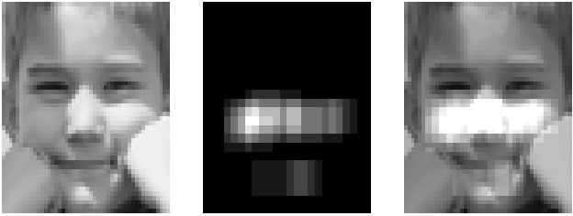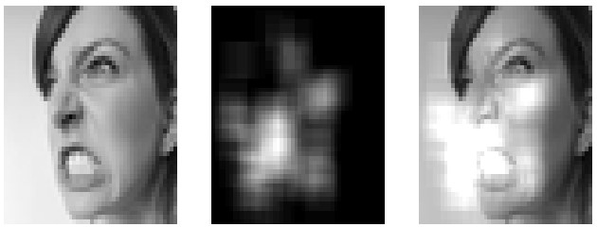
Fig. 1: The detected salient regions for different facial expressions by our model. The images in the first and third rows are taken from FER dataset.
This means that ideally, the machine learning framework should focus only on the important parts of the face, and less sensitive to other face regions. In this work we propose a deep learning-based framework for facial expression recognition, which takes the above observation into account, and uses attention mechanism to focus on the salient part of the face. We show that by using convolutional network, even a network with few layers (less than 10 layers) is able to achieve good results. We propose an approach based on a convolutional network, which can focus on feature-rich parts of the face.
- Literature Review







In one of the most iconic works in emotion recognition by Paul Ekman, happiness, sadness, anger, surprise, fear and disgust were identified as the six principal emotions (besides neutral). Ekman later developed FACS using this concept, thus setting the standard for works on emotion recognition ever since. Neutral was also included later on, in most of human recognition datasets, resulting in seven basic emotions. Image samples of these emotions are displayed in Figure 2.

Fig. 2: (Left to right) The six cardinal emotions (happiness, sadness, anger, fear, disgust, surprise) and neutral. The images belong to FER dataset.
Earlier works on emotion recognition, rely on the traditional two-step machine learning approach, where in the first step, some features are extracted from the images, and in the second step, a classifier (such as SVM, neural network, or random forest) are used to detect the emotions. With the great success of deep learning, and more specifically convolutional neural networks for image classification and other vision problems several groups developed deep learning-based models for facial expression recognition (FER). To name some of the promising works, Khorrami in showed that CNNs can achieve a high accuracy in emotion recognition and used a zero-bias CNN on the extended Cohn-Kanade dataset (CK+) and the Toronto Face Dataset (TFD) to achieve state-ofthe-art results.
Aneja et al developed a model of facial expressions for stylized animated characters based on deep learning by training a network for modeling the expression of human faces, one for that of animated faces, and one to map human images into animated ones. Mollahosseini proposed a neural network for FER using two convolution layers, one max pooling layer, and four “inception” layers, i.e., sub-networks. Liu in combines the feature extraction and classification in a single looped network, citing the two parts’ need for feedback from each other. They used their Boosted Deep Belief Network (BDBN) on CK+ and JAFFE, achieving state-of-the-art accuracy. Barsoum et al worked on using a deep CNN on noisy labels acquired via crowdsourcing for ground truth images. They used 10 taggers to relabel each image in the dataset, and used various cost functions for their DCNN, achieving decent accuracy. Han et al proposed an incremental boosting CNN (IB-CNN) in order to improve the recognition of spontaneous facial expressions by boosting the discriminative neurons, improving over the best methods of the time. Meng in proposed an identity-aware CNN (IA-CNN) which used identity- and expression-sensitive contrastive losses to reduce the variations in learning identity and expression-related information.

All of the above works achieve significant improvements over the traditional works on emotion recognition, but there seems to be missing a simple piece for attending to the important face regions for emotion detection. In this work, we try to address this problem, by proposing a framework based on convolutional network, which is able to focus on salient face regions.

- Proposed Framework

We propose an end-to-end deep learning framework, based on convolutional network, to classify the underlying emotion in the face images. Often times, improving a deep neural network relies on adding more layers/neurons, facilitating gradient flow in the network (e.g., by adding skip layers), or better regularizations (e.g. spectral normalization), especially for classification problems with a large number of classes. However, for facial expression recognition, due to the small number of classes, we show that using a convolutional network with less than 10 layers and attention (which is trained from scratch) is able to achieve promising results, beating state-of-the-art models in several databases.
Given a face image, it is clear that not all parts of the face are important in detecting a specific emotion, and in many cases, we only need to attend to the specific regions to get a sense of the underlying emotion. Based on this observation, we add an attention mechanism, through spatial transformer network into our framework to focus on important face regions.

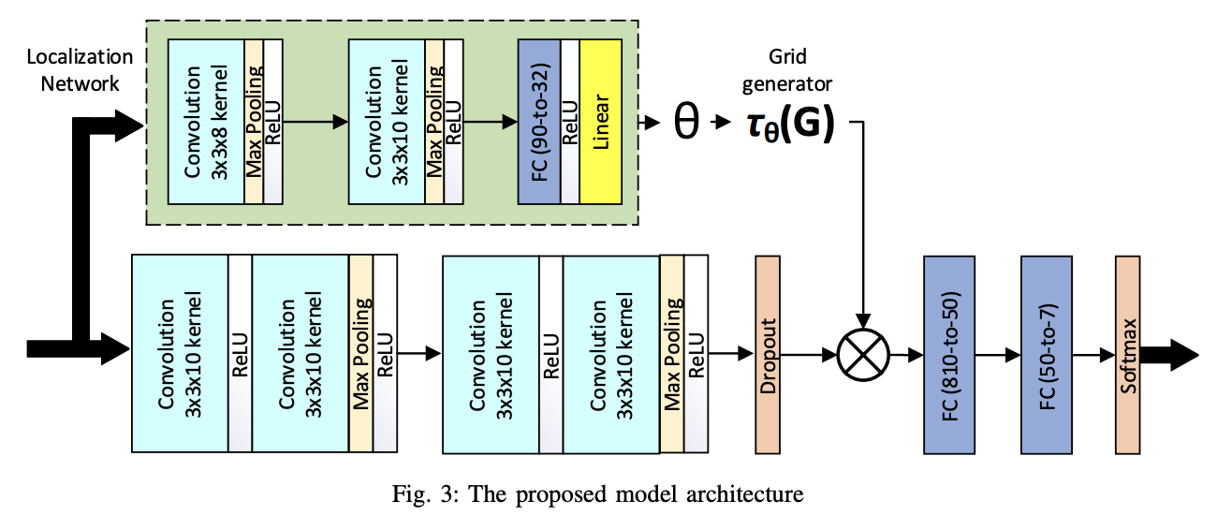
Figure 3: Illustrates the proposed model architecture. The feature extraction part consists of four convolutional layers, each two followed by max-pooling layer and rectified linear unit (ReLU) activation function. They are then followed by a dropout layer and two fully-connected layers. The spatial transformer (the localization network) consists of two convolution layers (each followed by max-pooling and ReLU), and two fully-connected layers. After regressing the transformation parameters, the input is transformed to the sampling grid producing the warped data. The Deep_Emotion model is a simple Convolutional Neural Network (CNN) designed to classify facial expressions into one of seven emotion categories (such as Angry, Happy, Sad, etc.). It is built using PyTorch and consists of two convolutional layers followed by two fully connected (dense) layers.
The model works as follows:
- First, the input image (a grayscale image with 1 channel) is passed through a convolutional layer (conv1) which applies 10 filters of size 3×3. This helps the network detect simple features such as edges and corners.
- The output is then passed through a second convolutional layer (conv2), which again applies 10 filters of size 3×3. This allows the model to recognize more complex features by combining the simpler ones learned earlier.
- After the convolutions, the multi-dimensional feature maps are flattened into a one-dimensional vector of size 810. This step prepares the data for the fully connected layers that follow.
- The flattened vector is then passed through a fully connected layer (fc1) that reduces it to 50 features. A ReLU activation function is applied to introduce non-linearity, enabling the model to learn more complex relationships.
- Finally, the data passes through a second fully connected layer (fc2) which outputs 7 values — each representing a different emotion class.
Throughout the model, the ReLU activation function is used after each convolution and after the first fully connected layer to introduce non-linearity and help the model learn better.
The model’s final output consists of logits (raw scores) for each of the 7 emotion classes. During training, these logits would typically be passed through a softmax function to convert them into probabilities.
This architecture does not use attention mechanisms. It relies solely on convolutional layers to extract features and fully connected layers to make the final classification.
In summary, the Deep_Emotion model is a straightforward CNN that learns patterns in facial images and uses them to predict emotions in a simple, efficient way.
The proposed model combines Convolutional Neural Networks (CNNs) with a Spatial Transformer Network (STN) module to improve classification accuracy by handling distortions, rotations, and other variations in input images.
It consists of two major parts:
- Localization Network
- Main Classification Network
Localization Network
- The first block in the architecture is the Localization Network.
- This is a small CNN that takes the input image and predicts the best spatial transformation (like rotation, scaling, translation) needed to align the image properly.
- It is made of:
  - Convolution Layers (3×3×8 kernel, then 3×3×10 kernel)
  - Max Pooling Layers (for down-sampling)
  - ReLU Activation Functions (for non-linearity)
  - Fully Connected (FC) Layer:
After convolutions, features are flattened and passed through a fully connected layer which outputs the transformation parameters (θ).
  - Linear Layer:
Finally, a simple linear layer outputs the final parameters without activation, since we don't want non-linearity here.
- Output: Transformation parameters θ\thetaθ are sent to the Grid Generator.
Grid Generator and Sampler
- The Grid Generator uses the parameters θ\thetaθ to create a sampling grid.
- The input image is warped according to this grid, producing a new "transformed" image.
- This new image is better aligned for recognition.

Main Classification Network
- After transformation, the new image is fed into the main CNN to perform feature extraction and classification.
- The main network consists of:
  - Convolution Layers (3×3×10 kernels repeated three times)
  - ReLU Activation after each Convolution (to introduce non-linearity)
  - Max Pooling Layers (to reduce spatial dimensions)
  - Dropout Layer (to prevent overfitting)
  - Fully Connected (FC) Layers:
    - First FC layer reduces features from 810 to 50.
    - Second FC layer reduces features from 50 to the final number of classes (7 classes here).
- The final output goes through a SoftMax Activation to give class probabilities.
Input Image
↓
Localization Network (small CNN → predicts θ)
↓
Grid Generator (builds new grid using θ)
↓
Sampler (applies grid to input image → new transformed image)
↓
Main CNN (feature extraction and classification)
↓
Fully Connected Layers
↓
SoftMax Output (final prediction)
Dataset Overview
FER2013: The Facial Expression Recognition 2013 (FER2013) database was first introduced in the ICML 2013 Challenges in Representation Learning [37]. This dataset contains 35,887 images of 48x48 resolution, most of which are taken in wild settings. Originally the training set contained 28,709 images,and validation and test each include 3,589 images. This database was created using the Google image search API and faces are automatically registered. Faces are labeled as any of the six cardinal expressions as well as neutral. Compared to the other datasets, FER has more variation in the images, including face occlusion (mostly with hand), partial faces, low-contrast images, and eyeglasses. Four sample images from FER dataset are shown in Figure 4.



Figure 4: Four sample images from FER dataset
- Results

FER-2013 dataset is more challenging than other facial expression recognition datasets we used. Besides the intra-class variation of FER, another main challenge in this dataset is the imbalance nature of different emotion classes. Some of the classes such as happiness and neutral have a lot more examples than others. We used the entire 28,709 images in the training set to train the model, validated on 3.5k validation images, and report the model accuracy on the 3,589 images in the test set. We were able to achieve an accuracy rate of around 70.02% on the test set. The confusion matrix on the test set of FER dataset is shown in Figure 8. As we can see, the model is making more mistakes for classes with less samples such as disgust and fear. The comparison of the result of our model with some of the previous works on FER 2013 are provided in Table I.
Method | Accuracy Rate
Bag of Words [52] | 67.4%
VGG+SVM [53] | 66.31%
GoogleNet [54] | 65.2%
Mollahosseini et al [19] | 66.4%
The proposed algorithm | 70.02%

Table: Classification Accuracies on FER 2013 dataset

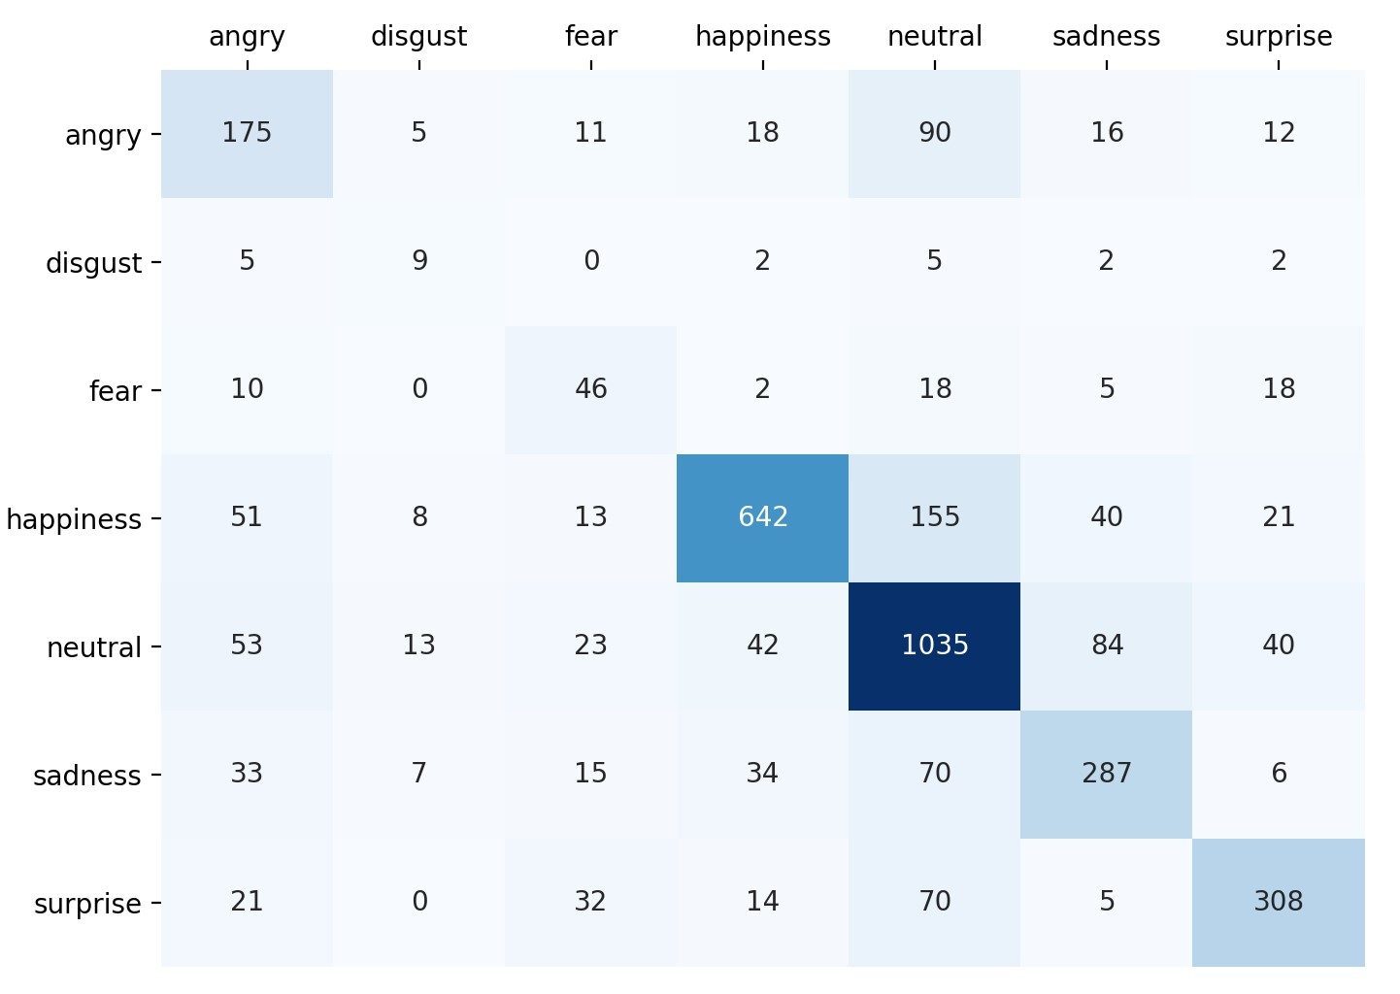
Fig. 8: The confusion matrix of the proposed model on the test set of FER dataset

For FERG dataset, we use around 34k images for training, 14k for validation, and 7k for testing. For each facial expression, we randomly select 1k images for testing. We were able to achieve an accuracy rate of around 51% accuracy with 100 epochs.

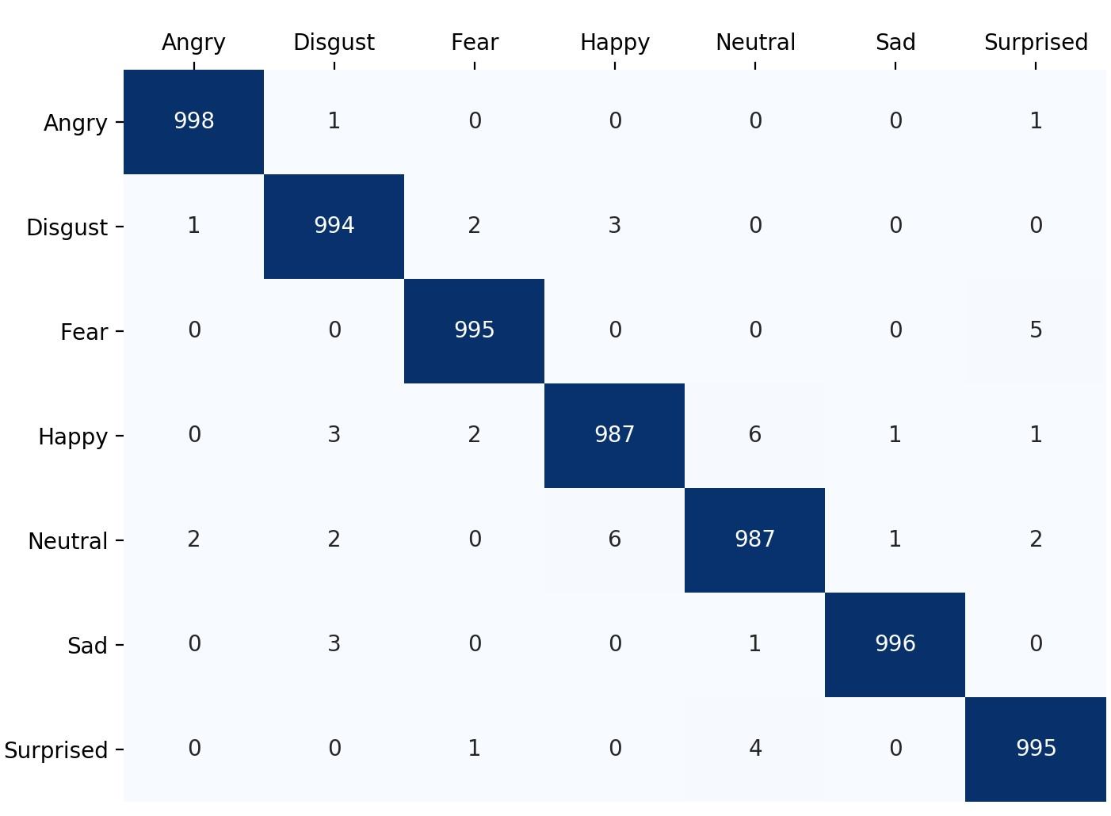
Fig. 9: The confusion matrix on FERG dataset

Some of the sample output

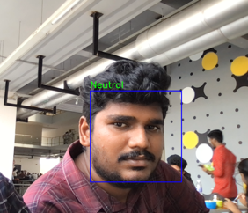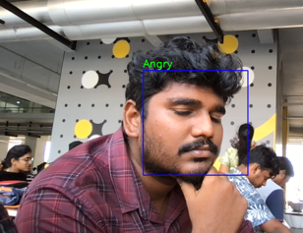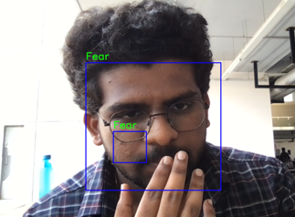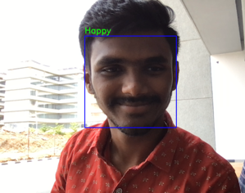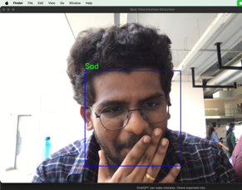

In this project, we successfully built and trained a custom CNN model (Deep_Emotion) to classify emotional expressions in images.
The model was trained using images from the dataset folder with a batch size of 128, learning rate of 0.005, and for 100 epochs.
Data augmentation was done through normalization.
During training, we observed that the training accuracy gradually increased while both training and validation losses decreased, indicating that the model was learning effectively.

Conclusion
In this project, we successfully developed a custom deep learning model called Deep_Emotion for the purpose of emotion recognition from images.
We began by understanding the basics of deep learning and convolutional neural networks (CNNs), which are highly effective in image-based tasks. Instead of using a pre-trained model, we designed and built the entire architecture from scratch using PyTorch, giving us full control over the model's layers and parameters.
We structured the project in the following way:
- Implemented a custom dataset loader (Plain_Dataset) to read, transform, and feed the image data into the model.
- Built the Deep_Emotion model manually, using several convolutional, activation, pooling, and fully connected layers, focusing on extracting meaningful features from facial images.
- Applied data transformations like normalization to ensure faster convergence during training.
- Designed a full training pipeline, including:
  - Forward propagation
  - Loss calculation using CrossEntropyLoss
  - Backward propagation and optimization using the Adam optimizer
- Split the dataset into training and validation sets to monitor both performance and overfitting.
During the training phase, we carefully tracked:
- Training Loss
- Validation Loss
- Training Accuracy
- Validation Accuracy
Over the course of training, the model showed a clear decrease in both training and validation loss, and an increase in accuracy, indicating that it successfully learned meaningful patterns from the data.
Finally, after training for the specified number of epochs, the model’s parameters were saved for future evaluation and deployment.
REFERENCES

- Cowie, Roddy, Ellen Douglas-Cowie, Nicolas Tsapatsoulis, George Votsis, Stefanos Kollias, Winfried Fellenz, and John G. Taylor. ”Emotion recognition in human-computer interaction.” IEEE Signal processing magazine 18, no. 1: 32-80, 2001.

- Edwards, Jane, Henry J. Jackson, and Philippa E. Pattison. ”Emotion recognition via facial expression and affective prosody in schizophrenia: a methodological review.” Clinical psychology review 22.6: 789-832, 2002.

- Chu, Hui-Chuan, William Wei-Jen Tsai, Min-Ju Liao, and YuhMin Chen. ”Facial emotion recognition with transition detection for students with high-functioning autism in adaptive e-learning.” Soft Computing: 1-27, 2017.

- Khorrami, Pooya, Thomas Paine, and Thomas Huang. ”Do deep neural networks learn facial action units when doing expression recognition?.” Proceedings of the IEEE International Conference on Computer Vision Workshops. 2015.

- Giannopoulos, Panagiotis, Isidoros Perikos, and Ioannis Hatzilygeroudis. ”Deep Learning Approaches for Facial Emotion Recognition: A Case Study on FER-2013.” Advances in Hybridization of Intelligent Methods. Springer, Cham, 1-16, 2018.

- Zhang, T., Zheng, W., Cui, Z., Zong, Y., & Li, Y. Spatialtemporal recurrent neural network for emotion recognition. IEEE transactions on cybernetics, (99), 1-9, 2018.

- Lyons, Michael J., Julien Budynek, and Shigeru Akamatsu. ”Automatic classification of single facial images.” IEEE transactions on pattern analysis and machine intelligence 21.12: 13571362, 1999.

